**Austin Stephens**

**Assignment 02**

**1/28/16**

1. My code successfully stores the correct values in the variables a, b, x, and y and then performs the correct operation to give the correct output of 20.

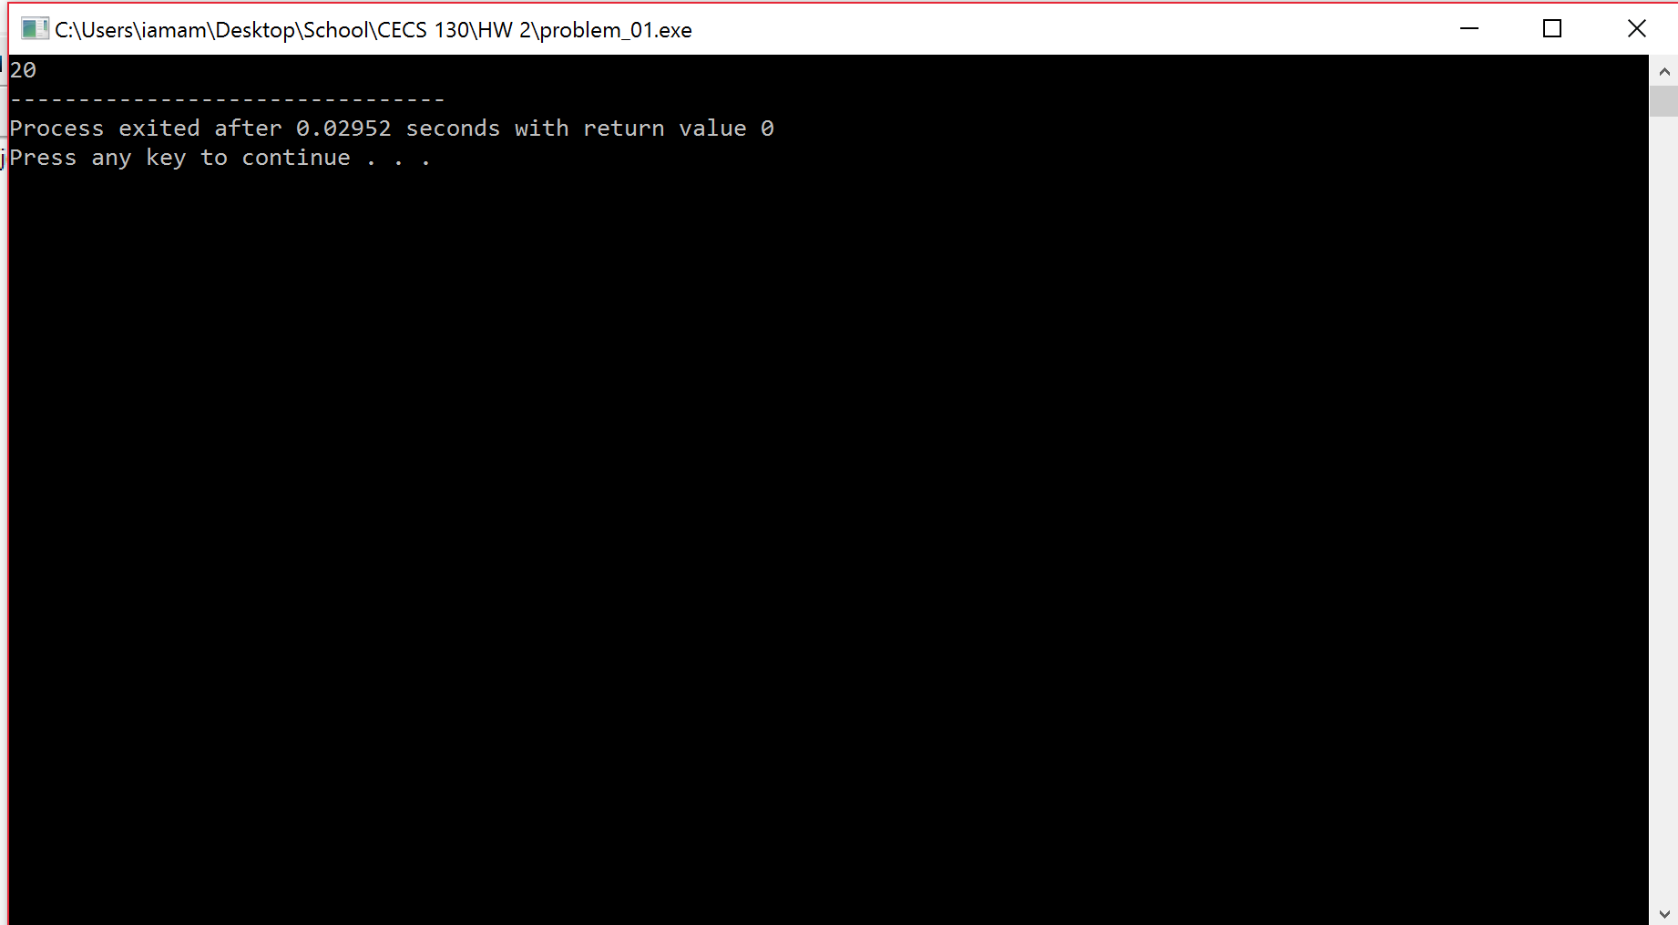

1. I wrote a program that performs the same operation as problem one except this time it allows the user to input whichever four values they want to use. I used the same inputs as problem one as a test and then another set of numbers, they both gave the correct output.

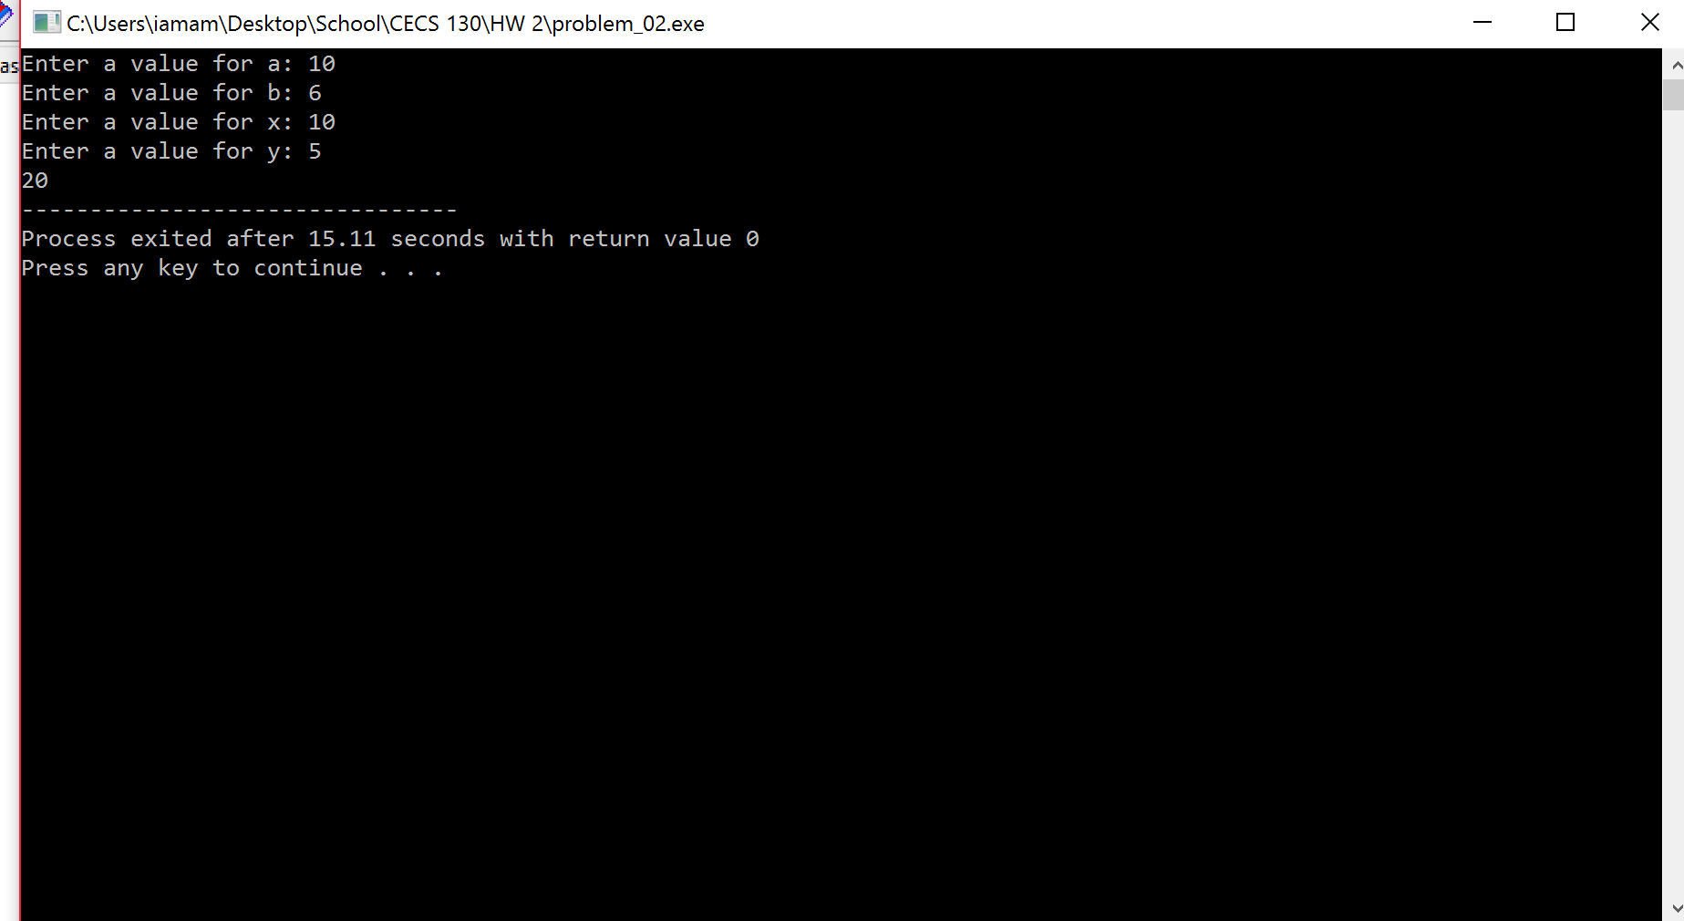

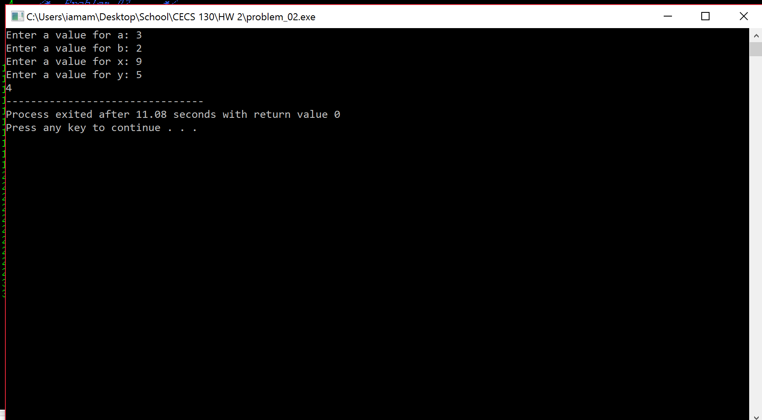

1. My program successfully takes in three values, commission rate, price, and cost, and then stores them as floats. Those values are then used in the calculation given in the problem to give a value for the commission made on a sale. The program then returns a float with two decimals which is the amount made on commission to the cent.

